**Blood Bank System**

Database class project 2020/2021

|  |  |  |  |  |
| --- | --- | --- | --- | --- |
| Student Name in English | Student Name in Arabic | Student ID | Section | Work percentage |
| Omama kittaneh | أمامة كتانة | 11819305 | 8-9.5 | 100% |
|  |  |  |  |  |
|  |  |  |  |  |

Date/time

---------------------------------------------This section is intended for the Instructor---------------------------------------

|  |  |
| --- | --- |
| **Topic** | **Mark** |
| Project Requirements and Modeling |  |
| Correctness of Database mapping |  |
| Functional Dependency and Normalization |  |
| Project Tools |  |
| Project Discussion |  |
| Project Completeness |  |
| Project Output Results or reporting (JasperReport, charts, graphs, etc.) |  |
| Project Administration and Management |  |
| Project Report |  |
| Project Idea |  |
| Project Complexity |  |
| Team work |  |
|  |  |
|  |  |
|  |  |

**Abstract**

**Blood bank its program to help the employee to record patient data,and retrieve it quickly ,and record donor data within standard such as weight and age ,and let’s up to donor to denote specific patient ,and program to count the price requirement from each patient ,and details for units blood available for emergency situations.**

**Contents**

**Introduction ……………………………….…………………………………………………………………………...3**

**Requirements …………………………………………………………………………………………………………..4**

**Functional Dependency……………………………………………………………………………………………..5**

**UML Class Diagram for Clinics Database…………………………………………………………………….9**

**Jasperreport Design……………………………………………………………………………………………..…..10 3NF…………………………………………………………………………………………………………………………11**

**Discussion About Our Project GUI…………………………………………………………………………….12**

**Conclusion,tools and references………………………………………………………………………………..20**

**Introduction**

We program and design a program for central blood bank in Ramallah,

We store important information about patient ,donor ,and unit available in blood bank.

It helps the employee to sort information about patient. starting from first name ,phone , blood type,etc.and store information about donor his name,weight,age ,phone,etc.Then,the accounting belonging to patient and number of unit needed and number of unit ,and unit was donated by donor, it gives data for unit available in blood bank.

**Requirements**

**Each Patient in Central Blood Bank in Ramallah has Patient Name, a unique Patient Id, Patient Blood Group, age, unique phone number ,number of unit needed , and each donor in it has donor name, a unique donor Id,city and age donor Blood Group which possible matches another patient and save him, donor weight and age to even allow him to donate or not, donor Contact number to contact him in emergency ,number of unit he donate it, donate for specific patient we keep track the blood bank number of unit available for each type of blood , and we keep track of accounting part and the cost of unit blood before** discount and after to calculate the required amount.

**Functional Dependency**

**1-Patient table**

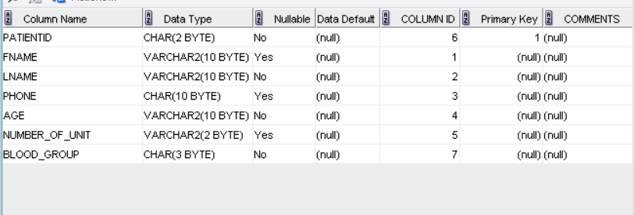

**Patientid->fname,lname,phone,age,number_of_unit,blood_group**

**2-Donor table**

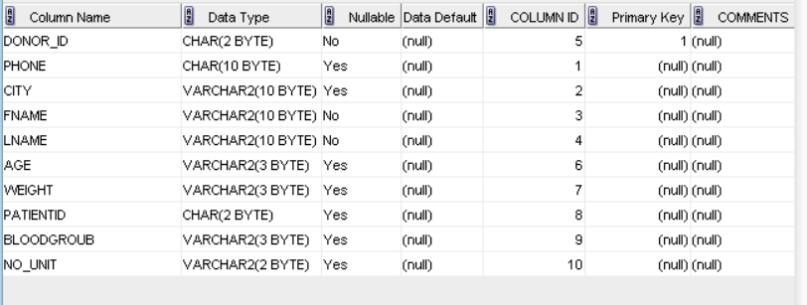

**donorid->Fname,lname,phone,age,weight,blood_group**

**3-Accounting table**

There is not functional dependence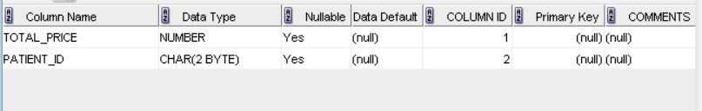

Patient_id->total_price

**4-Blood bank table**

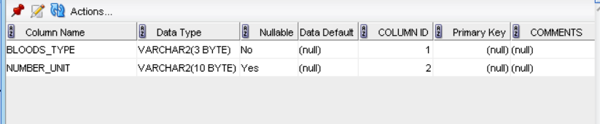

There is not functional dependence

**UML Class Diagram for Blood bank Database**

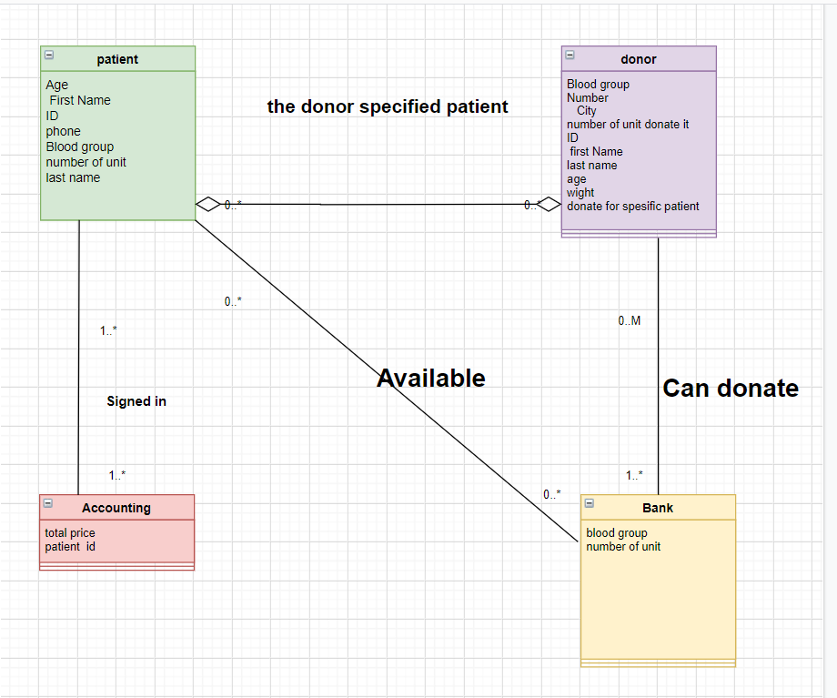

10

**Jasperreport Design**

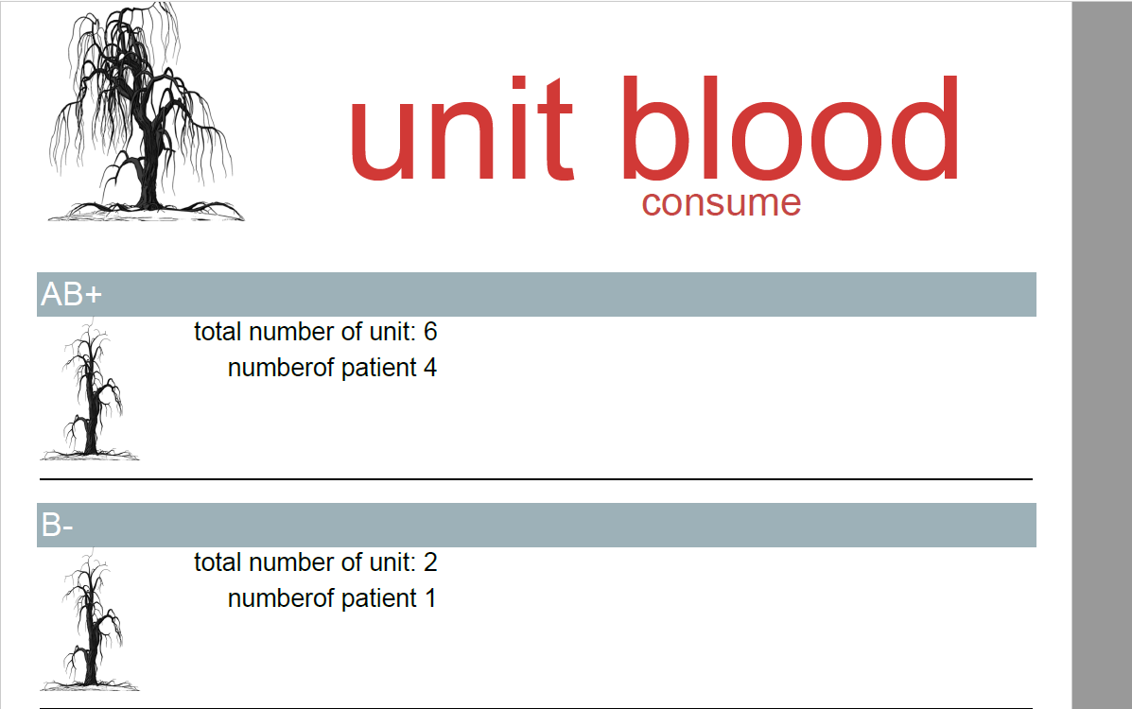

**This report count the number of unit consume by every patient**

**3NF**

ALL tables are in 3NF**.**

1NF: they in which the intersection of every column and record contains only one value.

2NF: they don’t have any composite key.

3NF:there is no non primary key column is transitively dependent n the primary key.

**Discussion About Our Project GUI**

**-log in interface**

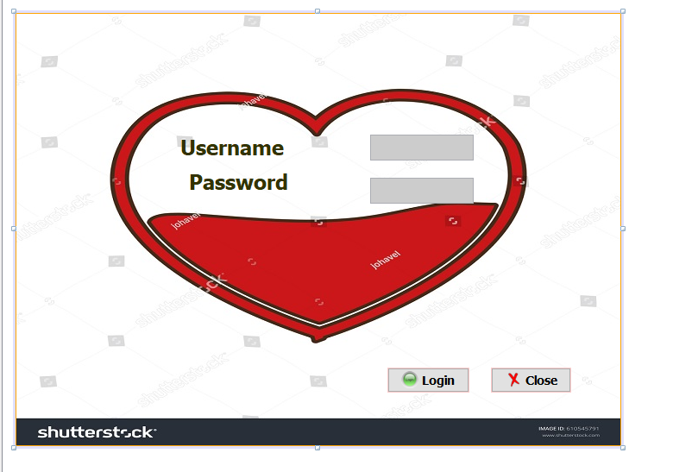

**it’s a log in interface to the employee should add the username “omama”,and correct password “omama”,**

**Then close page .**

**-Home interface**

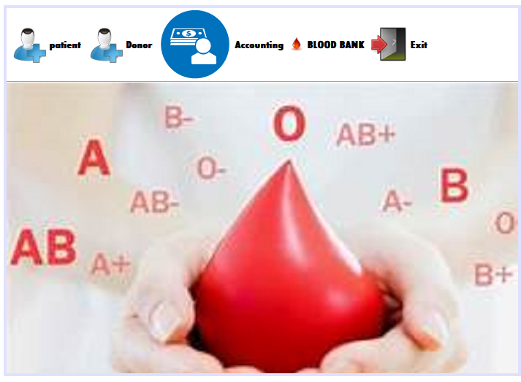

**This page has many menu bar, first menu item for adding new patient ,second one for adding new donor, third for count required price for all patient ,finally for show number of unit available for each blood type, and exit item have two option first log out and back to log in interface, or exit to exit hole program completely.**

**-Add new patient**

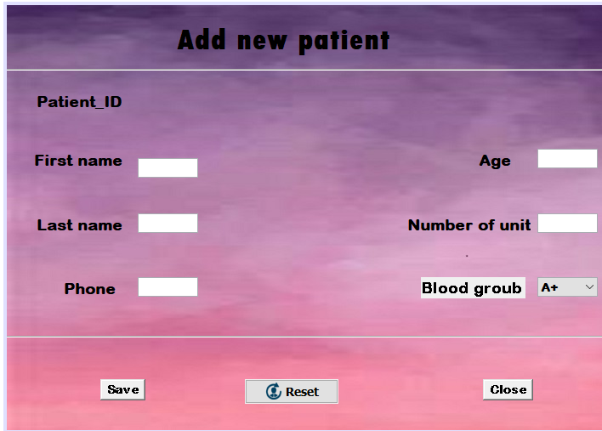

**This interface to add new patient, and theirs label increase automatically in case open new page, and multiple text field to add name, phone ,age ,number of unit ,jcombobox to add type of blood group, save this data by press save button then clear jtextfield by reset button, then close this interface.**

**-Add new donor**

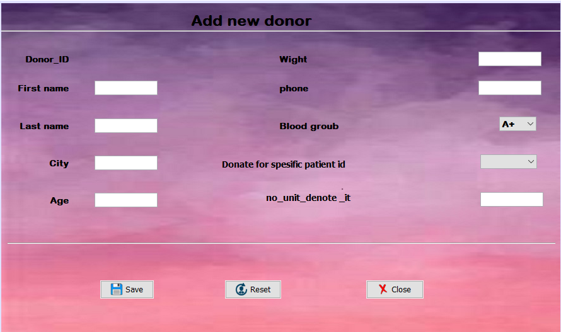

**This interface to** to register donor information**,** . After filling the text filed and considering age bigger than 17 and weight more than 50,and donate for specific patient or not then click button save to save data ,and close interface.

**-Accounting**

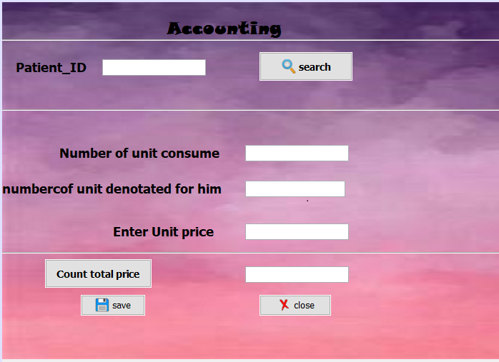

**This interface to count total bill for each patient, by adding patient id ,**

**Then click search, then appear at two text field number of unit consume by patient ,next number of unit denoted for him by specific donor , then enter the price for each unit ,then click count total price button and save this bill.**

**-Blood bank**

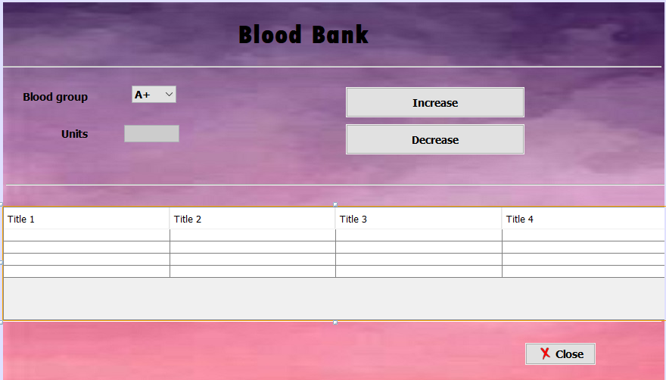

**This interface appear number of unit available for each type of blood group, and we can increase and decrease number of unit**

**By each button.**

**Conclusion**

this program will be helpful for the employee how work in this bank it organizes all the data which the employee needs. the data sort in the database and displayed in the program. the program makes arrive at it easier. it also helps patients in emergency, and make the process easier, I hope you like it.

**Tools Used in my Project**

1-**NetBeans** for programming the project

2.Sql developer and sql plus for database-

2.Drawio for UML diagram

3. Jasper soft studio for jasper report

4. Word documents

5. Text documents

**References**

<https://www.youtube.com/channel/UCFnpoiQiCEJ5fM3rAeJDYUg>

<https://stackoverflow.com/>

https://examples.javacodegeeks.com/